

2012 Promotional Examination II
Pre-university 2

H1 CHEMISTRY 8872 / 02
Paper 2 Structured Questions
10 Sep 2012
(MONDAY)
Candidates answer Section A on the Question Paper.
2 hours
Additional Materials: Data Booklet

READ THESE INSTRUCTIONS FIRST

FOR EXAMINER’S USE
SECTION A
Q1 | / 7
Q2 | / 10
Q3 | / 10
Q4 | / 13
SECTION B
Q__ | / 20
Q__ | / 20
Total | / 80
Do not open this booklet until you are told to do so.

Write your name, index number and class on all the work you hand in.
Write in dark blue or black pen on both sides of the writing paper.
You may use a soft pencil for any diagrams, graphs or rough working.
Do not use staples, paper clips, highlighters, glue or correction fluids.

Section A
Answer all questions.

Section B
Answer two questions on separate answer paper.

You are reminded of the need for good English and clear presentation in your answers.

The number of marks is given in brackets [ ] at the end of each question or part question.

At the end of the examination, arrange your answers in numerical order and fasten all your work securely together.

SECTION A
Answer all questions in the space provided.
1 |  | Apricot kernels contain glycoside amygdalin, an organic compound which turns into deadly hydrogen cyanide acid, HCN, when the kernel is crushed or injured. High doses of hydrogen cyanide can cause coma with seizures and cardiac arrest, leading to death in a matter of minutes. A fatal dose for a human can be as low as 1.50 mg kg⁻¹ of body weight. (1 mg = 1.00 x 10⁻³ g)  The forensics department of the local law enforcement agency was trying to determine the cause of death of a 75 kg deceased man who was found at home on the couch with a few empty packets of apricot kernels lying on the ground.  A 10 cm³ sample of blood (a typical human has 71 cm³ of blood per kg body mass) obtained from the body and hydrogen cyanide containing haemoglobin was isolated and dissolved to form 25 cm³ of solution. This sample of haemoglobin was oxidised by potassium dichromate, K₂Cr₂O₇, to determine the amount of Fe²⁺ which is also equal to the amount of hydrogen cyanide present. 1.70 cm³ of 0.00100 mol dm⁻³ acidified K₂Cr₂O₇ solution was required for complete reaction.
 | (i) | Write a redox equation between Fe²⁺ and Cr₂O₇²⁻. | [1]
 |  | 6 Fe²⁺ + Cr₂O₇²⁻ + 14 H⁺ 6 Fe³⁺ + 2 Cr³⁺ + 7H₂O
 | (ii) | Show by oxidation number that the reaction in (i) is a redox reaction. | [1]
The oxidation number of Fe increases from +2 in Fe²⁺ to +3 in Fe³⁺.
The oxidation number of Cr decreases from +6 in Cr₂O₇²⁻ to +3 in Cr³⁺.
 | (iii) | Calculate the total amount of hydrogen cyanide, HCN in the 25 cm³ of solution. | [2]
Amount of Cr₂O₇²⁻
= (1.70/1000) x (0.00100)
= 1.70 x 10⁻⁶ mol

Amount of Fe²⁺
= 6 x amount of Cr₂O₇²⁻
= 6 x 1.70 x 10⁻⁶
= 1.02 x 10⁻⁵ mol

Hence amount of HCN = 1.02 x 10⁻⁵ mol
 | (iv) | Calculate the amount of hydrogen cyanide, HCN, in the body of the deceased man. | [1]
Amount of HCN in the body of the deceased man
= (1.02 x 10⁻⁵ / 10) x 71 x 75
= 5.431 x 10⁻³ mol

 | (v) | Calculate the concentration of HCN in mg kg⁻¹ and hence determine if the cause of death was due to hydrogen cyanide poisoning. | [2]
Mass of HCN
= 5.431 x 10⁻³ x ( 1.0 + 12.0 + 14.0)
= 0.1466 g
= 146.6 mg

Concentration of HCN in mg kg⁻¹
= 146.6 / 75
= 1.954 mg kg⁻¹
 |  | [Total: 7 marks]

2 | (a) | Ethanol is an increasingly important ‘bio-fuel’ as it can be produced from renewable sources as such sugar-cane and other plants.
 | (i) | Define, with the aid of an equation, the standard enthalpy change of combustion of ethanol. | [2]
The standard enthalpy change of combustion of ethanol is the energy change when one mole of ethanol is completely burnt in oxygen under standard conditions of 298 K and 1 atm.
CH₃CH₂OH(l) + 3O₂(g) → 2CO₂(g) + 3H₂O(l)
(state symbols required)
 | (ii) | 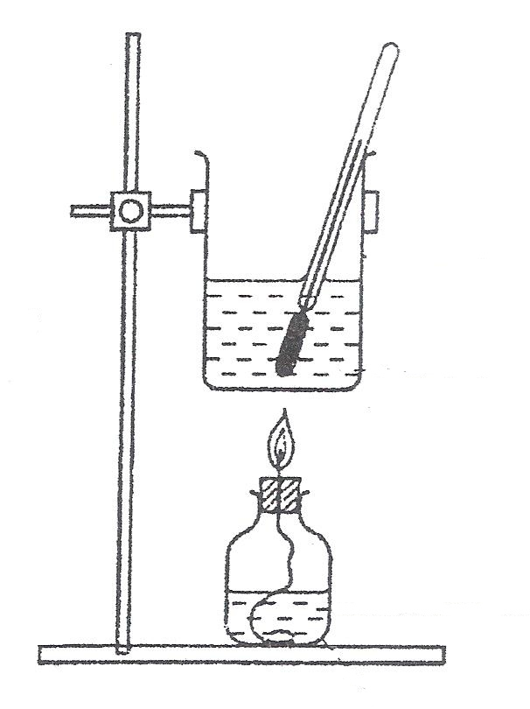The figure below shows a diagram of a calorimeter used by a student to determine the enthalpy change of combustion of ethanol.  thermometer  small metal can  spirit lamp containing ethanol  wick  water
 |  | When 0.96 g of ethanol was combusted in a calorimeter, the energy evolved heated 100 cm³ of water from 28.0 °C to 65.3 °C. Given that this process is only 70% efficient, use these data and values from the Data Booklet to calculate the enthalpy change of combustion of ethanol. | [3]
Heat absorbed by water
= 100 × 4.18 × (65.3 − 28.0)
= 15600 J
= 15.6 kJ

Heat evolved from combustion of ethanol
= 15.6 × 100/70
= 22.3 kJ
burnt
=
= 0.0209 mol
ΔH_{c} (ethanol)
= −
= −1070 kJ mol⁻¹ (to 3 s.f.)

 | (iii) | Suggest a possible reason why only 70% of the heat produced from the combustion is used to warm the water. | [1]
Heat produced from the combustion could be lost to the surroundings during the heat transfer from the flame to the water/ from the warm water (especially without the use of a lid).

Or

Some of the heat produced from the combustion is absorbed by the metal can.
 | (b) | An accurate value for the standard enthalpy change of combustion of ethanol is −1370 kJ mol⁻¹. Suggest why the value calculated in (a)(ii) is still less than the accurate value despite having taken into account the efficiency of heat transfer to the water. | [1]
 |  | Combustion of ethanol may be incomplete due to inadequate supply of oxygen near the flame.
 | (c) | Use the bond energies given in the Data Booklet to calculate another value for the standard enthalpy change of combustion of ethanol. | [2]
CH₃CH₂OH(l) + 3O₂(g) → 2CO₂(g) + 3H₂O(l)

ΔH_{c}(CH₃CH₂OH)
= [E(C–C) + 5E(C–H) + E(C–O) + E(O–H) + 3E(O=O)] − [4E(C=O) + 6E(O–H)]
= [(+350) + 5(+410) + (+360) + (+460) + 3(+496)] − [4(+740) + 6(+460)]
= −1012 kJ mol⁻¹
= −1010 kJ mol⁻¹ (to 3 s.f.)
 | (d) | Suggest a reason for the discrepancy between this value and the accurate value given in (b). | [1]
The value for ΔH_{c}(CH₃CH₂OH) obtained from bond energies is not accurate as the bond energies quoted from the Data Booklet represent average bond energies derived from the full range of molecules that contain the particular bonds.

CH₃CH₂OH and H₂O are in the liquid state under standard conditions but calculation in (c) makes use of bond energies which relate to breaking of covalent bonds in gaseous molecules.
 |  | [Total: 10 marks]

3 | (a) | Bromoethane can be hydrolysed by aqueous sodium hydroxide to form ethanol. Results of an investigation into the kinetics of this reaction are given below.  experiment number [CH₃CH₂Br] /mol dm⁻³ [NaOH(aq)] / mol dm⁻³ relative initial rate  1 0.10 0.20 1.00  2 0.20 0.10 1.00  3 0.30 0.20 3.00
 | (i) | Use the data in the table to deduce the order of reaction with respect to CH₃CH₂Br and with respect to NaOH. Hence write an overall rate equation for the reaction. | [3]
Using experiments 1 and 3:

As [CH₃CH₂Br] is tripled while [NaOH] is kept constant, rate is tripled. Hence the reaction is first order with respect to CH₃CH₂Br / the order of reaction with respect CH₃CH₂Br is 1.

Let rate = k[CH₃CH₂Br][NaOH]^{n}
Using experiments 1 and 2:
= =
= 1
n = 1
Hence the reaction is first order with respect to NaOH / the order of reaction with respect NaOH is 1.
∴ Rate = k[CH₃CH₂Br][NaOH]
 | (ii) | Using experiment 1, calculate a value for the rate constant, giving its units. | [2]
Using experiment 1,
1.00 = k(0.10)(0.20)
k = 50.0 mol⁻¹ dm³ s⁻¹
 | (iii) | Explain what is meant by the term activation energy. | [1]
 |  | The activation energy is the minimum amount of energy that reactant particles must possess before a reaction could occur.
 | (b) | Describe how the activation energy is affected by the presence of a catalyst, and explain how this increases the rate of reaction. | [2]
 |  | A catalyst provides an alternative reaction pathway with lower activation energy. As a result, more reactant particles possess the energy required for an effective collision and the frequency of effective collisions increases. The rate of reaction is thus increased.

 | (c) | Explain, in molecular terms, how the initial reaction rate would be affected by changing the concentration of reactants in a reaction. | [2]
 |  | The rate of reaction generally increases with the concentration of one or more of the reactant species. As the concentration of the reactant is increased, the number of reactant particles per unit volume increases. Consequently, there will be an increase in the frequency of effective collisions between the reactant particles.
 |  | [Total: 10 marks]

4 | (a) | Compound W has the molecular formula C₅H₈O₃. When W is refluxed with acidified potassium manganate(VII), only one organic product, X, is obtained. When W is warmed with aqueous sodium hydroxide and iodine, a yellow precipitate is formed. W has no reaction when 2,4–dinitrophenylhydrazine is added. One mole of W liberates one mole of hydrogen gas when treated with sodium metal.
 | (i) | State the type(s) of reaction undergone when W is:
 |  | I) | warmed with aqueous sodium hydroxide and iodine. | [1]
 |  |  | Oxidation
 |  | II) | treated with sodium metal. | [1]
 |  |  | Reduction
 | (ii) | Name all the possible functional groups present in W. |  | [1]
 |  | Secondary alcohol, alkene, carboxylic acid
 | (iii) | Suggest the structure of W and hence identify the organic product X. |  | [2]
 |  | W: X:
 | (iv) | Write balanced equations for all the reactions which have occurred. |  | [3]
+ 6[O] + 2CO₂ + 2H₂O

+ 4I₂ + 7OH– + CHI₃ + 5I– + 6H₂O

+ 2Na + H₂

 | (b) | A Chemistry professor wanted his student to devise a synthetic method to convert methylbenzene to 2–nitro–3,5–dichloro acid. His student suggested this method:  The professor identified at least three errors in the above method of synthesis.
 | (i) | Identify the three errors and explain with reasons. | [3]
- K₂Cr₂O₇ is too mild an oxidizing agent and cannot oxidize the methyl side chain. (Acidified KMnO₄ has to be used).
- COOH is 3–directing NO₂ will not go into the second position.
- Absence of AlCl₃ and wrong condition for last step.
 | (ii) | Given the first step in the synthesis is as follows:
 |  | State the reagents and conditions for Steps II and III. | [2]
Step II: KMnO₄, H₂SO₄, heat under reflux
Step III: Cl₂ in AlCl₃, heat
 |  | [Total: 13 marks]

SECTION B
Answer two of the three questions in this section on separate answer paper.

1 | (a) | Compounds of aluminium and phosphorous differ in their behaviour with water.
 | (i) | Account for the difference in the reactions of aluminium oxide and phosphorus (V) oxide with water. | [2]
Al₂O₃ has a giant ionic structure with strong electrostatic forces of attraction between the oppositely charged ions. Due to the high lattice energy, it does not react with H₂O.

On the other hand, P₄O₁₀ has a simple molecular structure with weak temporary dipole – induced dipole attraction between molecules. It reacts with water to form an acidic solution, H₃PO₄.
 | (ii) | Explain the difference in the pH values when AlCl₃ and PCl₅ are separately dissolved in water. Write equations to support your answer. | [3]
Al₂Cl₆ undergoes both hydration and hydrolysis when dissolved in water. The high charge density of hydrated Al³⁺ ion enables it to attract electrons away from one of its surrounding water molecules, thereby polarising and weakening the O-H bond to a greater extent which results in the release of a proton and solution with pH 3.0.

AlCl₃ + 6H₂O [Al(H₂O)₆]³⁺ + 3Cl⁻
[Al(H₂O)₆]³⁺ [Al(H₂O)₅(OH)]²⁺ + H⁺

PCl₅ undergoes complete hydrolysis to form a strongly acidic solution of pH 2.0.
PCl₅ + 4H₂O H₃PO₄ + 5HCl
 | (b) | In each of the following reactions, describe the way in which the oxide of the named element is reacting and discuss whether its behaviour is what you would expect from the position of the element in the Periodic Table:
 | (i) | Silicon: MgO + SiO₂ → MgSiO₃
SiO₂ acts as an acidic oxide as it forms a salt with the basic oxide MgO.
It is acting as expected of a Group IV member as non-metal oxides are acidic.
 | (ii) | Beryllium: 2 NaOH + BeO → Na₂BeO₂ + H₂O | [3]
BeO acts as an acidic oxide as it formed a salt with the alkali NaOH.
It is not acting as expected of a Group II member as metal oxides are basic.

Due to high charge density of Be²⁺ ion, BeO shows a high degree of covalency, and is amphoteric like Al₂O₃. Hence, BeO also shows acidic properties and would react with alkali NaOH to give a salt, Na₂BeO₂ and water.

 | (c) | Ascorbic acid, also known as Vitamin C is required for the synthesis of collagen in humans. A diet which lacks vitamin C leads to a disease called scurvy. Ascorbic acid is known to be water soluble and is commonly used as food additives.  Ascorbic Acid
 | (i) | Name the four functional groups present in the ascorbic acid compound. | [2]
 |  | Ester, secondary alcohol, primary alcohol, alkene
 | (ii) | Explain in terms of structure and bonding, why ascorbic acid is water soluble. | [2]
 |  | The molecule consists of many –OH groups which allows it to form (intermolecular) hydrogen bonds with water molecules. Hence, ascorbic acid is water soluble.
 | (iii) | The ascorbic acid molecule was reacted with acidified potassium dichromate (VI) followed by 2,4-dinitrophenylhydrazine. Draw the structural formula of the product formed. | [2]
- For changing primary alcohol to carboxylic acid
- For reacting resultant ketone with 2,4-DNPH.

 | (d) | Benzene is used as the starting reagent for the production of many aromatic compounds shown below.
 | (i) | Give the corresponding structural formula for T. | [1]
 | (ii) | Suggest the reagents and conditions needed to convert S to U. | [1]
 |  | Cl₂, UV light / heat
 | (iii) | U can react with a suitable reagent to give W, C₉H₁₀, which exists as a pair of geometric isomers. Name the reaction for the formation of W and hence suggest the reagents and condition needed to form W. | [2]
Elimination reaction
Ethanolic sodium hydroxide, heat under reflux
 | (iv) | Draw the pair of geometric isomers of W. | [2]

- cis and trans arrangements
- correct groups
 |  | Total: [20 marks]
2 | (a) | Consider the following energy cycle involving propan-2-ol.  CH₃CH(OH)CH₃(l) + O₂(g) 3CO₂(g) + 4H₂O(l)  ΔH₁  3C(s) + 4H₂(g) + 5O₂(g)
 | (i) | What does ΔH₁ represent? | [1]
 |  | Enthalpy change of formation of CH₃CH(OH)CH₃(l)
 | (ii) | State the definition of Hess’ Law.
 |  | Hess’ Law states that the enthalpy change for a chemical reaction is the same, regardless of the route taken, provided that the initial states of the reactants and the final states of the products are the same.
 | (iii) | Using the following data, calculate ΔH₁.  Enthalpy change of combustion of carbon = −393 kJ mol⁻¹  Enthalpy change of combustion of hydrogen = −285 kJ mol⁻¹  Enthalpy change of combustion of propan-2-ol = −2006 kJ mol⁻¹ | [2]
ΔH₁ = ΔH_{c}(products) – ΔH_{c}(reactants)
= 3(−393) + 4(−285) − (−2006)
= −313 kJ mol⁻¹
 | (iv) | Explain why propan-2-ol is a weaker acid compared to propanoic acid. | [2]
 |  | Electron-withdrawing C=O group pulls electrons away from the O–H bond, making it easier for the H atom to be released as a H⁺. In addition, carboxylate ion, RCOO⁻, is stabilised by delocalisation of the negative charge on the two oxygen atoms, i.e. resonance effect.

 | (b) | P, C₆H₁₂O₂, is a neutral compound. Heating P with dilute sulfuric acid, followed by warming with acidified potassium manganate(VII) gives compounds Q, C₃H₆O₂, and R, C₃H₆O. Effervescence is observed when Q reacts with aqueous sodium carbonate. R reacts with 2,4-dinitrophenylhydrazine but not with Fehling’s solution.  Deduce the structural formula of P, Q and R. Explain the reactions described and write equations where appropriate. | [8]
Observations | Deductions
P, C₆H₁₂O₂, is a neutral compound. | P is likely an ester.
P is heated with dilute sulfuric acid, | P undergoes acidic hydrolysis to form carboxylic acid and alcohol.
followed by warming with acidified potassium manganate(VII) gives compounds Q, C₃H₆O₂, and R, C₃H₆O. | Alcohol produced is likely to be oxidized to form ketone, R.  Q is likely to be carboxylic acid.
Effervescence is observed when Q reacts with aqueous sodium carbonate. | Q is carboxylic acid. Effervescence is caused by the formation of CO₂.
R reacts with 2,4-dinitrophenylhydrazine but not with Fehling’s solution. | R undergoes condensation with 2,4-DNPH. It contains the ketone group.

Q is CH₃CH₂CO₂H
R is CH₃COCH₃
P is CH₃CH₂CO₂CH(CH₃)₂
 | (c) | Lactic acid has the following structural formula:  Lactic acid  It can be formed by 2 other chemical methods in a laboratory. Suggest a two-step reaction to convert the following compounds to lactic acid. State reagents and conditions in each step clearly and draw the structure of intermediate compounds formed.
 | (i) | ethanal
KCN, H₂SO₄(aq)
10 – 20°C
Dil. H⁺(aq)
reflux

 | (ii) | 2-chloropropan-1-ol | [6]
KOH(aq),
followed by
re-acidification

reflux
KMnO₄(aq) / H⁺
reflux

 |  | Total: [20 marks]

3 | (a) | The reaction in the Contact Process for manufacturing sulfuric acid is as follow.  2SO₂(g) + O₂(g) 2SO₃(g)  When sulfur dioxide and oxygen are mixed, the two gases slowly react to form sulfur trioxide according to the above equilibrium.
 |  | Sketch a graph to show how the rates of the forward and reverse reactions change from the time the two gases are mixed to the time when the reaction reaches equilibrium. Label the two lines clearly. | [1]
 |  | 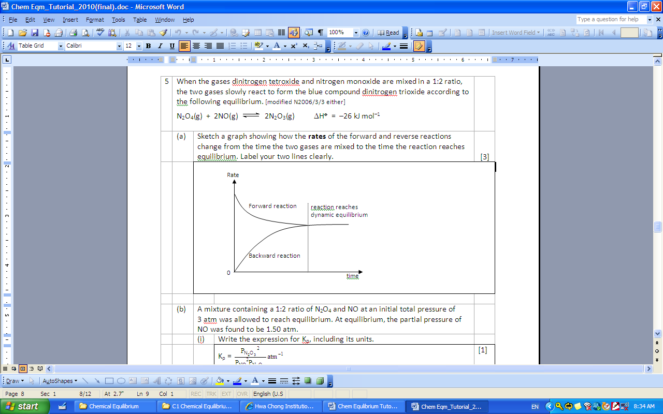
 | (b) | At a certain temperature, 2.0 mol of SO₂(g) and 1.0 mol of O₂(g) were introduced to a 2.0 dm³ flask. The equilibrium mixture was found to contain 1.6 mol of SO₃(g).
 | (i) | Write the expression for the equilibrium constant, K_{c}. | [1]
 |  | K_{c} =
 | (ii) | Calculate the equilibrium concentrations of SO₂(g), O₂(g) and SO₃(g) and hence the equilibrium constant, K_{c}, of the reaction at this temperature. | [2]
2SO₂(g) + O₂(g) 2SO₃(g)
Initial amt / mol 2 1 0
Change amt / mol –1.60 –0.80 +1.60
Eqm amt / mol 0.40 0.20 1.60

[SO₂] = 0.20 mol dm⁻³; [O₂] = 0.10 mol dm⁻³; [SO₃] = 0.80 mol dm⁻³
K_{c} = = 160 mol^{–1} dm³

 | (c) | The following are acids found in apples, oranges and grapes respectively.  malic acid citric acid tartaric acid
 | (i) | Draw the structural formula of the organic product formed when PCl₅ is added to malic acid. | [1]
 | (ii) | Describe a simple chemical test that can distinguish citric acid from the other two acids and describe what you would observe. | [3]
Either one
Reagents and conditions | Observations
 | Citric acid | Malic acid, tartaric acid
KMnO₄(aq), H₂SO₄(aq),  heat under reflux | Purple colour remains | Purple to colourless
K₂Cr₂O₇(aq), H₂SO₄(aq),  heat under reflux | Orange colour remains | Orange to green

 | (iii) | Show how malic acid can be converted to tartaric acid in the laboratory via two steps.  In your answers, show clearly the reagents, conditions and intermediate products involved. Write balanced equations for the reactions that occur. | [5]
Equations:
- HO₂CCH₂CH(OH)CO₂H → HO₂CCH=CHCO₂H + H₂O
malic acid
- HO₂CCH=CHCO₂H + H₂O + [O] → HO₂CCH(OH)CH(OH)CO₂H tartaric acid

 | (d) | Malic acid, C₃H₅O₃CO₂H(aq), in apple juice can be considered to be a weak monobasic acid that dissociates partially in water as shown:  C₃H₅O₃CO₂H(aq) C₃H₅O₃CO₂⁻(aq) + H⁺(aq)
 | (i) | The pH of a sample of apple juice is 2.50.  Calculate the molar concentration of hydrogen ions, [H⁺], in the juice. | [1]
 |  | [H⁺] = 0.00316 (or 3.16 x 10⁻³) mol dm⁻³
 | (ii) | In a titration reaction, 20.0 cm³ of the apple juice was found to react completely with 23.30 cm³ of 0.15 mol dm⁻³ NaOH(aq). Calculate the concentration of malic acid in the juice. | [2]
= = 1

[malic acid] = 0.175 mol dm⁻³
 | (iii) | Explain the difference in the results obtained in parts (i) and (ii). | [1]
[H⁺] << [malic acid]
This shows that malic acid is a weak acid which dissociates partially in water.
 | (iv) | Suggest, with a reason, a suitable indicator for the titration. | [1]
 |  | Phenolphthalein. pH at the end-point of weak acid-strong base is above 7 and this corresponds to working range of phenolphthalein
 | (v) | The aqueous solution of malic acid and sodium malate constitutes a buffer system.  With the aid of suitable equations, explain how such a system works when: | [2]
 |  | small amount of alkali is added.
Small amount of alkali is readily removed from the solution by reacting with the large reserves of C₃H₅O₃CO₂H.

C₃H₅O₃CO₂H + OH⁻ → C₃H₅O₃CO₂⁻ + H₂O

Hence the pH of the buffer remains relatively constant.
 |  | small amount of acid is added.
Small amount of acid is readily removed from the solution by reacting with the large reserves of C₃H₅O₃CO₂⁻ ions.

C₃H₅O₃CO₂⁻ + H⁺ → C₃H₅O₃CO₂H

Hence the pH of the buffer remains relatively constant.
 |  | Total: [20 marks]

BLANK PAGE

